Site Characterisation Professional Services Support (SCPSS)
Framework

Request For Information (RFI)

C26888
GDF-NWS-SCPS-AXX-CC-CS-000004

PAGE INTENTIONALLY BLANK

Document Control

Name | Role | Signature | Date
Originator:  Piotr Bednarski | Business Partner (Procurement) |  | 24/11/2025
Reviewer:  Owen David | Senior Project Manager |  | 25/11/2025
Approval:  Andrew Batstone | Senior Commercial Lead | 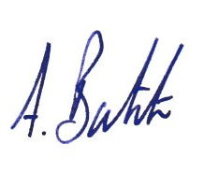 | 25/11/2025

Version Control

Version | Amendment | Approval | Date
01 – Draft | Various | Approved | 24/11/2025
02 – To Issue | N/A | Approved | 25/11/2025
03
04
05
06
07
08
09
10
11

Contents
1 Background 6
2 Document Purpose 6
3 RFI Schedule 6
4 Submission and Communication 7
5 Opportunity description 7
6 The Contracting Authority 7
7 Scope Overview and Lot Structure: 7
7.1 Lot 1 – Site Characterisation Planning and Technical Advisory 8
7.2 Lot 2 – Geological and geophysical Interpretation 8
7.3 Lot 3 – Hydrogeological interpretation 8
7.4 Lot 4 – Laboratory analyses and reference method development 8
8 Framework Information 9
9 Route to Market 10
10 Indicative Procurement Timetable 11
11 Further Market Engagement Information 11
Appendix 1 - Supplier Response Form 12

Abbreviations and Definitions

CoP | Conditions of Participation
e.g. | Example
ITT | Invitation to Tender
KPIs | Key Performance Indicators
MAT | Most Advantageous Tender
NDA | Nuclear Decommissioning Authority
NWS | Nuclear Waste Services
RFI | Request For Information
SCDP | Site Characterisation Delivery Partner
SCP | Site Characterisation Plan
SCPSS | Site Characterisation Professional Services Support
CPV Codes
71313000 | Environmental engineering consultancy services
71351200 | Geological and geophysical consultancy services

Background
Following publication of UK1: Pipeline Notice on 15th September 2025 (ref. 2025/S 000-056643), informing the market about an upcoming procurement opportunity, the Contracting Authority (Nuclear Waste Services) is now publishing UK2: Preliminary Market Engagement Notice to start engaging with suppliers and gather feedback to shape its procurement. The publication of this RFI document is the first stage of planned market engagements. For information about further engagements, please refer to the section ‘Further Market Engagement Information’ of this document.

Document Purpose
The purpose of this document is to provide further information to the market in relation to the NWS’s forthcoming Site Characterisation Professional Services Support (SCPSS) procurement opportunity by giving background information about NWS, site characterisation, scope overview and proposed procurement principles.
The Contracting Authority would also like to gain a better understanding of the capacity and appetite of the market to deliver the required services. Through this RFI document NWS intends to gather feedback from interested suppliers in relation to the scope overview, lotting structure, proposed delivery models, procurement timescales and identify any key issues that the market may perceive with what is being proposed.
To support that, the Contracting Authority requests suppliers to complete and submit ‘Supplier Response Form’ appended to this document (Annexure 1). The form consists of numerous questions to provide an answer to and area to raise any matters relating to this procurement that the Contracting Authority should consider early and pose any questions.
NWS will review all the responses received, will consider them and, where appropriate, will incorporate the content submitted by any organisation, hence the NWS’s early thinking may change as a result of this and future stages of market engagement.
For the avoidance of doubt, the market engagement exercise is not part of the formal procurement process, which will only begin after the publication of Tender Notice. Involvement in the market engagement does not prejudice or preclude other organisations from taking part in the subsequent procurement. Any decision by an organisation to respond or not respond to the early market engagement will have no impact on or reflect in any manner on any future procurement process.

RFI Schedule
Activity | Date
RFI Response Open - Publication of UK2: Preliminary market engagement notice | 25th November 2025
RFI Response Deadline | 18th December 2025

Submission and Communication
Please respond to this opportunity by downloading this document, completing Supplier Response Form (Annex 1) and submitting the completed document to:
gdfmajorprocurements@nuclearwasteservices.uk
Following receipt and review of the RFI responses, the Contracting Authority may publish questions raised by interested suppliers and NWS’s responses to them, on the webpage.

Opportunity description
Site Characterisation Professional Services Support (SCPSS) framework has the overall objective of providing Nuclear Waste Services (NWS) with comprehensive professional services support for site characterisation activities, across multiple potential sites. This framework excludes physical works.

The Contracting Authority
As a pioneer of nuclear technology, the UK has accumulated a legacy of higher activity radioactive waste and materials. This is being stored safely on an interim basis at nuclear sites across the UK. More will be produced as existing facilities reach the end of their life and are decommissioned and through the operation of new nuclear power stations.
Nuclear Waste Services (NWS) is a wholly owned subsidiary of the Nuclear Decommissioning Authority (NDA) and was created with the vision and purpose to provide nuclear waste solutions making nuclear waste permanently safe, sooner.
One of the strategic objectives of NWS is to ensure that the right waste form is in the right package, in the right facility. As a consequence, NWS undertakes site evaluation to understand the potentially suitability of sites to dispose of waste. Site characterisation is a process within site evaluation. Site characterisation includes the development of subsurface or geoscientific understanding, through a series of studies and investigations.

Scope Overview and Lot Structure:
Site Characterisation Professional Services Support (SCPSS) will be multi supplier framework to provide NWS with comprehensive professional services support for site characterisation activities.
In order to enable NWS access to a broad and deep pool of expertise, the framework scope was divided into following four Lots:

- Lot 1 – Site Characterisation Planning and Technical Advisory
- Lot 2 – Geological and geophysical Interpretation
- Lot 3 – Hydrogeological interpretation
- Lot 4 – Laboratory analyses and reference method development

Lot 1 – Site Characterisation Planning and Technical Advisory
This lot encompasses the development and implementation of Site Characterisation Plans (SCPs), aligned with UK regulatory frameworks and technical strategies, to support site characterisation. Site characterisation plans may be required for multiple sites, in both inshore and onshore environments. This may include management arrangements and process development for regulatory submissions, strategic planning of characterisation activities, and the design and specification of site investigation works. This lot also includes the provision of Technical Advisory Services which may include technical reporting, technical drafting and the provision of assurance support.

Lot 2 – Geological and geophysical Interpretation
This lot encompasses the geological and geophysical interpretation activities required to support the development of Site Descriptive Models (SDMs) across multiple sites and basins, reflecting evolving data availability, uncertainty, and project maturity. This includes seismic interpretation and quantitative seismic analysis, basin-to-borehole scale geological assessments, and the integration of multidisciplinary datasets to inform geological understanding.

Lot 3 – Hydrogeological interpretation
This lot encompasses the research and technical development required to characterise and model hydrogeological and hydrogeochemical systems to underpin Site Descriptive Models (SDMs) and support disposal facility designs. This includes but not be limited to; hydrogeological modelling and interpretation across multiple sites, conceptual and numerical groundwater flow and transport modelling, and the characterisation of aquifer systems using data from legacy laboratory and field techniques.

Lot 4 – Laboratory analyses and reference method development
This lot encompasses Laboratory analysis that may provide a range of underpinning data sets for the conceptual design of disposal facilities. This includes the analysis of physical samples to provide both current day geosphere properties as well as developing techniques to understand property evolution into the future. A key aspect to understand in these work packages will be the coupled nature of properties, for example understanding links between hydraulic and mechanical properties in mudrocks. Another key part of the laboratory testing programme is the development of reference methods.

Framework Information
Framework Duration: The framework will have a 3-year initial term with 2 x 1-year possible extensions.
Anticipated Contract Start: September 2026
Anticipated Contract End: September 2029 (without extension)
Anticipated Value: TBC
Framework Structure: Closed Framework with 4 Lots with limited number of suppliers per Lot
Proposed Contract Type: Professional Services Contract
Proposed Contract Terms: TBC
Pricing Mechanism: Call-off contracts placed under the Framework Agreement may be based on one of the following charging models:
- Fixed price (preferred pricing method)
- Time and materials
- Target Cost
Call-Off Award mechanism: Competitive Selection Process for the majority of call-off contracts, an Award Without Competition Procedure for e.g. below threshold value using ‘objective mechanisms’ like 'taxi-rank' system or ‘highest ranking’ system
Key Performance Indicators: KPIs will be used to measure performance throughout the framework duration. There will be non-incentivised KPIs, but the Contracting Authority is also considering inclusion of incentivised KPIs. Some of the KPIs may be published.
Social Value & Sustainability: The SCPSS framework suppliers will be contractually obliged to deliver / comply with the commitments that they make in relation to social value and sustainability during the procurement process. The proposed approach to social value and sustainability delivery is to link the value generated by commitments to the value of awarded framework call-off contracts. The bidders will be required to bid back a firm commitment in terms of the value of annual social value delivery as a proportion/percentage of the estimated annual value of awarded call-offs.
Conflicts of Interest: There are no bidding/award restrictions between the Site Characterisation Professional Services Support (SCPSS) and Site Characterisation Delivery Partner (SCDP)

Route to Market
The procurement to be conducted in accordance with the PA23 and under Competitive Flexible Procedure. The following design to the Competitive Flexible Procedure is envisaged:
- Conditions of Participation (CoP) Stage
- Tender Stage

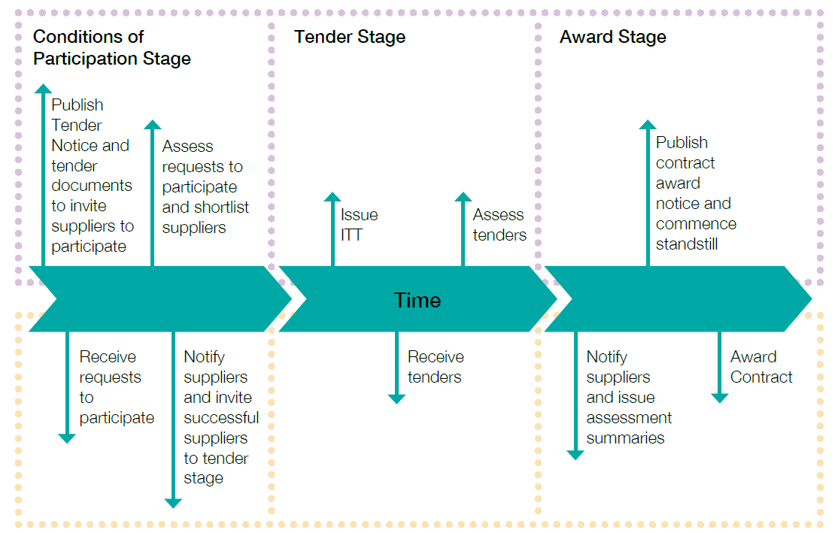
Conditions of Participation Criteria - potential tenderers will be assessed against the Excluded and Excludable Criteria, and Debarment List prior to assessment against a number of scored project specific questions to determine experience and capability. NWS will down select and invite remaining suppliers to tender
Contract Award Criteria will be the Most Advantageous Tender (MAT). The relative weighting of quality versus cost will be confirmed, however current weightings are:

Technical | 60%
Commercial | 30%
Social Value | 10%

Indicative Procurement Timetable
Event | Indicative Dates
UK4 Tender Notice (invitation to participate) | Early Spring - 2026
Deadline for receipt of request to participate | Early Spring - 2026
Assessment of Conditions of Participation | Early Spring - 2026
Invitation to Tender | Late Spring - 2026
Deadline for receipt of tenders | Late Spring - 2026
Evaluation of tenders against Award Criteria | Summer – 2026
UK6 Contract Award Notice | Summer – 2026
Framework commencement | Autumn - 2026

Further Market Engagement Information
Following publication of this RFI, the Contracting Authority wishes to pursue an ongoing market engagement up the point of formal tender release to involve the market in shaping both procurement strategy and tender documentation. This ongoing engagement will mainly have a form of dedicated webpage which the Contracting Authority will use to share with the market the latest documentation concerning SCPSS procurement to gather suppliers’ feedback. The Contracting Authority also intends to hold a live webinar for all interested suppliers that registered for it that will allow for real-time interaction with attendees and help to reach a wider audience, particularly suppliers based outside the UK. Following webinar, NWS would still like to offer suppliers an opportunity for real-time interaction, however instead of prescribing a specific time, the suppliers will be able to arrange “one-to-one” session (online or in-person) on an ad-hoc basis to discuss specific areas. The below table outlines an indicative timescale for SCPSS market engagement:

Form of Market Engagement | Indicative Timescale
Launch of SCPSS webpage | 25th November 2025
Issue Request for Information (RFI) | 25th November 2025
Webinar | January 2026 (exact date TBC)
SCPSS documentation share via webpage | Ongoing and until publication of Tender Notice (exact date TBC)
Ad hoc calls and/or meetings | Following webinar and up until publication of Tender Notice (exact date TBC)

It is important that interested organisations monitor the Find a Tender Service and the Atamis e-procurement portal for further notices about the upcoming engagements.

Appendix 1 - Supplier Response Form
By responding to this RFI, you are registering interest in SCPSS framework hereby allowing NWS to utilise your contact details to enable further engagement in relation to this procurement opportunity.
General
Organisation Name:
Respondent Name:
Respondent Contact Email address:
Respondent’s Role within the Organisation:
Please provide the main reason for registering interest in this framework opportunity.
CPV Codes
Could you propose any other CPV codes in addition to those listed in this document, that would be suitable to capture the relevant market interest for the forthcoming tender?
Lotting Structure and Capability
What do you think about the proposed lotting structure? Would you divide the lots differently? Are the lots opening the procurement up to SME participation?
Lot 1 Site Characterisation Planning and Technical Advisory Services
Can your organisation undertake this Lot?
Which capability/expertise can your organisation demonstrate against this Lot?
Additional comments in relation to this Lot

Lot 2 Geological and Geophysical Interpretation
Can your organisation undertake this Lot?
Which capability/expertise can your organisation demonstrate against this Lot?
Additional comments in relation to this Lot

Lot 3 Hydrogeological interpretation
Can your organisation undertake this Lot?
Which capability/expertise can your organisation demonstrate against this Lot?
Additional comments in relation to this Lot

Lot 4 Laboratory analysis and reference method development
Can your organisation undertake this Lot?
Which capability/expertise can your organisation demonstrate against this Lot?
Additional comments in relation to this Lot

Contract Duration
Do you believe the framework initial term and extension options is optimal contract duration?
Contractual Principals
Is the proposed contract type appropriate for the services required?
In relation to call-off award mechanism, do you think there would be a benefit of using objective mechanism like 'taxi-rank' system or ‘highest ranking’ system? Do you have experience using such mechanisms?
What would be appropriate incentive mechanism, adequate to the framework purpose, value, duration etc.?
Please provide any contractual requirements that could prevent you from bidding for this opportunity that the Contracting Authority should carefully consider.
Procurement Approach
What is your view on the proposed sourcing model, multi supplier, multi lot closed framework? Do you think that other options e.g. open framework or use of existing frameworks or Dynamic Markets could provide better outcome?
What do you think about the proposed 2 stage procurement procedure? Is the number of stages adequate to this procurement?
The Contracting Authority would like to bring capabilities of some small and medium-sized enterprises (SME) into this contract. What could be the potential barriers for SMEs for this type of contract that Contracting Authority must consider to allow SME participation?
Procurement Timetable
In relation to the proposed procurement timetable, do you think it is achievable? If you think it should be extended, please provide arguments.
Other Comments / Observations
Do you have any other comments / observations relating to this contract opportunity or further market engagements?

All suppliers are solely responsible for their costs and expenses incurred in connection with the preparation and submission of their response to this RFI. Under no circumstances will NWS be liable for any costs or expenses borne by the supplier or any of its supply chain members or advisors in this RFI.

