Site Characterisation Professional Services Support

Self-Funded Incentive (SFI) Handbook

C26888
GDF-NWS-SCPS-AXX-CC-CS-000003

PAGE INTENTIONALLY BLANK

Document Control

Name | Role | Signature | Date
Originator:  Andrew Batstone | Commercial Strategy Lead (Infrastructure)
Reviewer:  Nalan Stamper | Procurement Business Partner
Approval:  TBD | GDF Programme Manager - Enabling

Version Control

Version | Amendment | Approval | Date
01 – Draft
02
03
04
05
06
07
08
09
10
11

Contents
1 Purpose of this document 6
1.1 Overview 6
1.2 When Does SFI Apply 6
1.3 How will it be notified 6
2 Overview of the SFI 6
2.1 What is the SFI? 6
2.2 Which factors will determine the SFI performance calculation? 6
3 Funding and applicability of the SFI 7
3.1 How will the funding work for the SFI? 7
3.2 Which costs is the SFI Retention applicable to? 8
4 Management of performance 8
4.1 Reporting performance 8

Definitions

Authority: | Means Nuclear Waste Services Ltd (NWS) “The Client”.
Framework Agreement: | The overarching agreement which governs the relationship between the Consultant and the Authority. The Framework Agreement will set out the mechanisms by which the Authority can instruct the Consultant to deliver services through the issue of Work Orders.
Milestones: | Specific Deliverables within the Work Order
SFI | Self-Funded Incentive is the mechanism where the Consultant puts at risk a percentage of their costs against performance output.
Work Order Level Indicators (WOLIs): | Metrics that are applied to individual Work Orders and scored monthly for the purposes of the Performance KPI.
SFI Retention: | A fixed percentage retention (10%) that is a withheld from each application for payment, subject to specific exceptions.
Work Orders | An instruction from the Authority to the Consultant to perform a specific scope of work or defined set of services, within the overall scope of work and services under the Framework Agreement.
Performance Metrics Table | Document detailing available metrics which can be used on Work Orders.

Purpose of this document

Overview
The purpose of this document is to articulate the principles of the Self-Funded Incentive Mechanism (SFI) which is proposed for inclusion within the Site Characterisation Professional Services Support (SCPSS) procurement as an option to be used on a Work Order specific basis. This document is intended to create a common understanding of the core principles and implications of the SFI mechanism to support market engagement and legal drafting of schedules in preparation for the procurement.
This document should be read in conjunction with the Performance Metrics Table.

When Does SFI Apply
SFI will only be applied on Work Orders where the Authority believes there to be sufficient importance on the deliverable and/or programme and where the Work Order is of sufficient value to make the SFI model work. It shall be the exception rather than the rule

How will it be notified
Any Work Order which is subject to SFI will clearly state this in the documentation issued as part of the Mini-Competition.

Overview of the SFI

What is the SFI?
The Self-Funded Incentive (SFI) is a contract mechanism which will be used to incentivise SCPSS Consultants performance on a particular Work Order which is of such importance to the Authority to warrant its inclusion. The value of the SFI will be 10% of all applications for payment, subject to specific exclusions as set out in 3.2 below.

Which factors will determine the SFI performance calculation?
Three components will be measured and will form the basis of the SFI mechanism:
- Performance (25% of the SFI = 2.5% withheld value): The Performance will be measured using the defined Work Order Level Indicators covering: Quality, Cost, Time, Health & Safety, Security, and Environment.
- Social Value & Sustainability (25% of the SFI = 2.5% withheld value): Delivery of the Social Value Plan commitments in the Work Order
- Milestone performance (50% of the SFI = 5% withheld value): Measures the on-time delivery of Milestones e.g. geotechnical report completion.

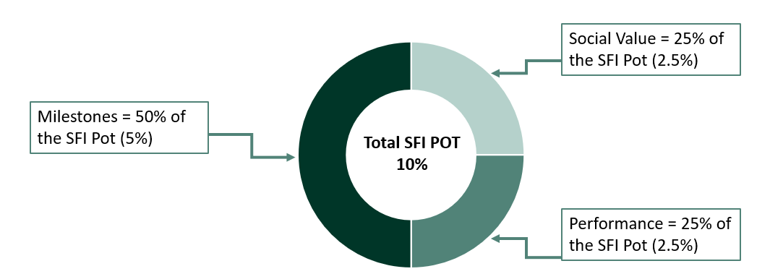

Figure 1: Illustration of SFI retention
Milestones
Milestones will be clearly stated or agreed between the parties prior to the commencement of any Work Order, these can be structured in a way that there are clear deliverables to be measured but that maintains cashflow.

Performance Metrics
The Performance element will be captured through Work Order Level Indicators (WOLI’s) which will be taken from the SCPSS Performance Metrics Table, this is a suite of metrics which can be selected as applicable to the Work Order. Additional WOLI’s maybe added to the Table throughout the term of the Framework and used as necessary. All applicable WOLI’s will be clearly stated in the Work Order documentation either as part of a Mini-Competition or Award without Competition pricing exercise.

Social Value
The Social Value Plan will be applicable to all Work Orders and the benchmark rate will be used to determine the minimum amount of Social Value to be delivered, the Consultant shall produce a Social Value delivery plan outlining what and how the social value will be delivered, this will be part of the returnable when submitting a proposal as part of a Mini-Competition or Award without Competition pricing exercise.

Funding and applicability of the SFI

How will the funding work for the SFI?
For each Work Order commissioned under the Framework where SFI applies the Authority will withhold 10% of each application for payment for that Work Order, forming the SFI Retention. Further detail on the applicability to invoice components is outlined below.
The SFI will only retain the costs associated with the Work Order it is applicable to and will set out a recovery mechanism in line with the Work Order programme.

Which costs is the SFI Retention applicable to?
The SFI will be deducted from individual Work Order applications for payment as follows:
- Will be deducted from all applications for payment except those amounts set out below:
- Will not be applicable to:
  - routine expenses (e.g. authorised travel, accommodation, subsistence); or
  - expenses identified by the Authority as a Work Order-specific expense (e.g. licences or equipment).

Management of performance

Reporting performance
All Work Orders will have Work Order Level Indicators (WOLI’s) applied to them to monitor performance, this in conjunction with the milestones and the social value plan will form the basis for the monthly report.
Milestone payment will be completed once the conditions for the milestone have been met to the satisfaction of the Authority.
Retentions on Performance and Social Value will be paid out at the end of the Work Order provided that the conditions have been met.

Failure to meet performance
Should the Consultant fail to meet the metrics required including; Performance, Social Value requirements as set out in the Work Order the retained sums set out for that aspect shall be retained by the Authority. This does not affect the other measures within the SFI mechanism, therefore if Milestone and Social Value delivery is maintained these retentions will be paid in accordance with the payment schedule.

