Site Characterisation Delivery Partner

Pricing Approach - Summary for the Market

C23206

GDF-NWS-SCDP-AXX-CC-CS-000017

PAGE INTENTIONALLY BLANK

Document Control

Name | Role | Signature | Date
Originator:  Tony Potts | Senior Business Partner (Procurement) |  | 19/6/25
Reviewer:  Andrew Batstone | Commercial Strategy Lead (Infrastructure) | 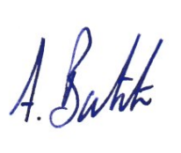 | 27/06/2025
Approval:  TBD | GDF Programme Manager - Enabling

Version Control

Version | Amendment | Approval | Date
0.1 – Draft
0.2 | Incorporating AB comments | A Potts | 19/06/25
03
04
05
06
07
08
09
10
11

Note: Within this document, the term “Consultant” applies to companies or individuals working in the capacity of consultant, contractor or supplier for the Site Characterisation Delivery (SCDP). The term “Client” shall be read to mean “Nuclear Waste Services” and “NWS”.
Contents
1 Purpose 6
2 Pricing – Cost Re-imbursement and Target Cost 7
2.1 Pricing of Task Orders 7
2.2 Consultant’s Direct Employees 7
2.3 Named Sub-contractor personnel 8
2.4 Expenses 8
2.5 Pricing Submission – Evaluation Model 8
2.6 Task Order 0 & 1 Price 9
2.7 Management Fee: Combined Profit % & Overhead % 9
2.7.1 Evaluation model used to compare bids and produce commercial evaluation scores 9
3 Subcontractors 11
APPENDIX A – Cost Allocation Matrix 12

Abbreviations and Definitions

NWS | Nuclear Waste Services
SCDP | Site Characterisation Delivery Partner

Purpose
This document is intended to provide potential Bidders with an opportunity to review (1) draft commercial proposals and (2) the pricing evaluation approach for the procurement process for the Site Characterisation Delivery Partner (SCDP) contract. All principles are indicative and are subject to change, feedback is welcomed on the proposals.
In developing this Pricing Approach NWS considered a range of options including a simple, single rate deck through to full NEC4 pricing. In proposing this ‘hybrid’ approach based on actual salary plus aggregated overhead and profit fee percentages NWS has sought to strike a balance between transparency and administrative effort in the management of costs.

Pricing – Cost Re-imbursement and Target Cost

Pricing of Task Orders
Task Orders may be priced on a Cost Re-imbursement, Target Cost or Fixed Cost basis as determined by the Client. NWS has a preference for using Target Cost or Fixed Cost pricing where the maturity of scope (for any given Task Order) allows.
Task Order 0 and Task Order 1 shall be priced on a Cost Re-imbursement basis.
The Price of Task Order 0 and 1 shall be set by the Client based on the estimates submitted by the Consultant at the tender stage against fixed resource schedules provided by the Client.
Subsequent Task Orders shall be priced by the Consultant against a Scope of Works provided by the Client and subject to the Clients acceptance.
The Client shall be seeking wherever possible to utilise the most cost predictable pricing method and the Consultant shall be encouraged to start work on a Cost Re-imbursement basis until such time as the scope of the Task is sufficiently defined to move to either a Target Cost or Fixed Cost mechanism.

Consultant’s Direct Employees
Work undertaken on a Cost Re-imbursement or Target Cost basis by the Consultant’s direct employees will be priced as follows:
Actual Salary + Overhead % Fee + Profit % Fee x hours worked
'Actual Salary' refers to the annual base salary which the resource will be paid by the Bidder, which will be subject to audit.
The Overhead % Fee and Profit % Fee combined are referred to as the ‘Management Fee’.
All other costs (other than agreed 'Routine Expenses' and ‘Agreed Task Order Costs’) and profit associated with the Consultants' proposal are to be incorporated within the Management Fee (consisting of Overhead % Fee and Profit % Fee), which will then be applied as an uplift to the Actual Salary costs for each resource.
The Consultant sets out their Overhead % Fee and Profit % Fee at the initial Invitation to Tender Stage. They shall remain constant, subject to any adjustment mechanism set out in the contact, for the duration of the contract.
An indicative cost allocation matrix is provided in Appendix A, which identifies how NWS proposes that the Consultant identifies their Actual Salary, Overhead, and Profit proposals:
- Overhead %: To include all overhead costs including, but not limited to, the items identified in Appendix A.
- Profit %: Includes all other costs, risk items, or profit requirements which are not captured within the 'Allowable Cost' (comprising ‘Actual Salaries’, ‘Routine Expenses’ and ‘Agreed Task Order Costs’) and Overhead %.

Additional pricing assumptions
- Working hours will be based on an 8hr working day, 40hr working week – total full-time hours expected are 1,850hrs per year (excluding annual leave, sickness etc).
- The Management Fee shall cover all working locations with the exception of allowances for Offshore working not already covered by a person’s base actual salary (see below).
- The Management Fee shall be inclusive of all domestic and international relocation expenses.
- For Task Orders that require Offshore working, any offshore working allowances not covered by the persons base actual salary shall be an Expense and paid at cost, subject to a maximum limit to be set by the Client.
- As part of the procurement process all bids are to be submitted in British Pounds Sterling (£). The Management Fee shall include any exchange rate risk.
- NWS will retain a commercial audit right at the following intervals: Year 1 - every 6 months. Years 2 onwards - every 12 months. NWS will have a further right to audit where there is ‘due cause’. The right to audit will extend to tier 1 subcontractors of the Consultant. Tier 2 subcontractors will only be audited by exception, where there is due cause.
Due cause shall be determined by NWS but includes for example quality issues, errors in or late reporting of subcontractor costs.
- The Consultant’s rates and prices at tender stage shall remain valid for year 1 of the contract, the Consultant shall then submit a proposal increase to salaries based on the annual increase applied to all staff within the organisation(s) which shall be subject to audit.

Named Sub-contractor personnel
Named Sub-contractor personnel will be charged at a rate inclusive of all costs, overheads and profit charged by the subcontractor for the resource (‘Sub-contract Rate’). The Consultant will then be permitted to apply a Sub-Contract Profit % Fee to the actual Sub-contract Rate, which NWS will reimburse.
The Sub-Contract Profit % Fee shall be capped at 5%.
The Consultant will not be permitted to add any additional Overhead % Fee or Profit % Fee to the Sub-contract Rate. Any time spent by the Consultant procuring and managing subcontractors will not be chargeable as an "Allowable Cost" and so an allowance for this activity would need to be incorporated within Consultant’s Management Fee.

Expenses
Only ‘Routine Expenses’ (travel, accommodation, subsistence) covered by the Clients' expenses policy, within the stated limits, and any ‘Offshore Working Allowance’ will be reimbursable through the Allowable Cost mechanism. All other costs will not be eligible for reimbursement.
The Client may, as part of the Task Order process, identify ‘Task Order-specific’ items which are required to deliver a Task Order which would not ordinarily be required by the Consultant in its delivery of the services (e.g. supply of specialist equipment). Any such items will be specified by the Client, pre-authorised and paid as an 'Agreed Task Order Cost'.
Routine Expenses and Agreed Task Order Costs will be paid as a pass-through cost, without the application of the Management Fee (No Overhead % Fee or Profit % Fee).

Procurement Process, Pricing Submission – Evaluation Model
The evaluation of the pricing submission will constitute 20% of the overall 100% tender evaluation weighting (100%). The identified 20% is then further divided into two distinct components to identify the price competitiveness of a bid, summarised in the table below and explained in detail below:
Component | Purpose | Methodology | Weighting
Task Order 0 & 1 price | To provide an indicative estimate of the actual resource costs for delivering the first two Task Orders (0&1), incorporating the corresponding impact of the proposed Management Fee. Drives a comparison on indicative costs. | Bidders input the following into a fixed NWS resource profile:  - Actual Salaries of Task 0 staff (14 defined Core Team roles) and Task 1 staff (14 defined roles)  - Overhead %  - Profit % | (15% of the total Evaluation)
Management Fee: Combined Profit and Overhead %s | To set Bidders' proposed percentage for Profit and Overheads which will be applied throughout the life of the contract. | Bidders must state a separate Profit % and Overhead % which are added to create the Management Fee. | (5% of the total Evaluation)
Table 1: Bid price competitiveness summary

Task Order 0 & 1 Price
A Task Order 0 & 1 price will be generated during the procurement process by a Bidder pricing a fixed resource schedule provided by the Client for evaluation purposes. The fixed resource schedule for each Task Order will state the roles/grades required along with the Clients' estimate of the number of days for each Task Order over a set duration (12 months and 6 months respectively) to enable Bidders' prices to be compared. Bidders will be required to propose the named person that they will assign to the contract filling the grade/role profiles provided in the fixed resource schedule and input their ‘Actual Salaries’.

Management Fee: Combined Profit % & Overhead %
The Management Fee will incorporate Bidders' profit and overhead proposals, which will be applied throughout the contract to subsequent cost reimbursable Task Orders. The Management Fee will be evaluated against other Bidders' proposed Management Fee. Additionally, the Management Fee will be applied to Task 0 & 1 Actual Salaries to produce the Task 0 & 1 price.

Evaluation model used to compare bids and produce commercial evaluation scores
The proposed pricing evaluation model is 'Relative Pricing' for both the Task 0 & 1 prices, and separately for the Management Fee % proposal. A cap is proposed for both price evaluation components:
- Task 0 & 1 Price cap: Total fee to be capped at 2x the lowest technically acceptable Bidder's total for Task 0 & 1 price.
- Management Fee % cap: The total Management Fee incorporating overheads and profit %s is to be capped at 2x the lowest technically acceptable Bidder’s Management Fee.
Bidders that breach either of the identified caps will be awarded a score of zero % for the commercial evaluation (zero % out of 20% available).
Bidders that breach either of the identified caps and receive a commercial score of zero will NOT be excluded from the procurement for this reason.
A simple summary of the Relative Pricing model which will be applied to Bidders' Task 0 & 1 Price and Management Fee % proposals separately is as follows:
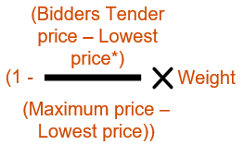
Relative Price Score =

*‘Lowest Price’ refers to the lowest priced technically acceptable bid.

Subcontractors
It is acknowledged that some Bidders wish to propose subcontractors to perform roles within Task 0 & 1. Where this is the case, Bidders will be required to state the Sub-contract Rate (as detailed above) to which Profit % Fee shall be applied.

APPENDIX A – Cost Allocation Matrix
The matrix below outlines the proposed Allowable Cost, Overhead and Profit categorisations for use under the contract. Bidders are to structure the Management Fee proposal for the applicable Overhead % and Profit % based upon the identified allocations.

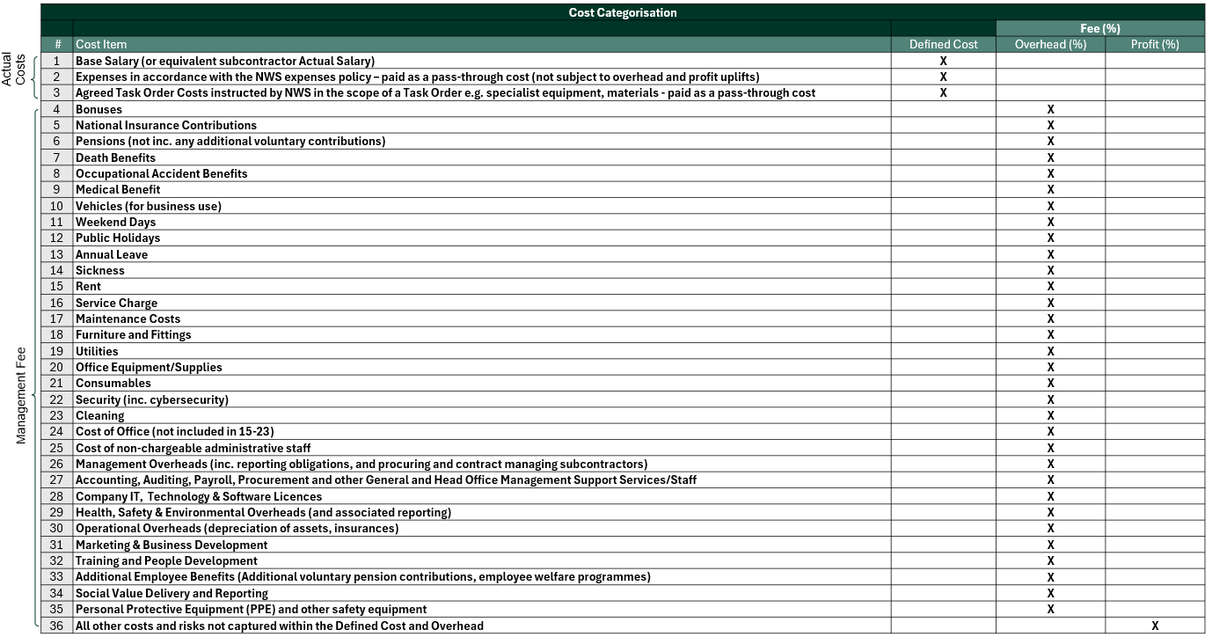
Bidders are required to ensure that all costs that it wishes to recover outside of the Actual Salary of the employee (or equivalent subcontractor Actual Salary) are captured within the Management Fee.

